NAME........................................................................................................................

INDEX NO..................................................SIGNATURE............................................

273/1

**GEOGRAPHY**

**PAPER 1**

JULY/AUGUST 2016

2HOURS 30 MIN

WESTERN JOINT MOCK EXAMINATIONS

Uganda Certificate of Education

**GEOGRAPHY**

**PAPER1**

2HOURS 30 MINUTES

**INSTRUCTIONS TO CANDIDATES:**

* This paper consists of parts I and II.
* Part I and section A of Part II are **compulsory**
* Answer only **one** question from section B of part II.
* Answers to all questions must be written in the answer sheets provided
* Any additional question(s) answered will not be marked.

**PART I**

**OBJECTIVE TYPE QUESTIONS (30MARKS)**

**1.** Which of the following areas in East Africa has the lowest population density?

A. Shores of lake Victoria B. Lower slopes of mt Kilimanjaro

C. Central Tanzania D. Kigezi highlands

2. Which one of the following results from the process of leaching?

A. Clay B. Limestone C. Laterite D. Sandstone

3. Wildlife in East Africa has been mainly conserved in gazetted areas in order to:

A. Attract tourists B. Maintain soil fertility

C. Promote scientific studies D. Protect valuable plants and animals

4. Which of the following mountains in East Africa experiences weathering by frost

Action?

A. Moroto B. Rwenzori C. Usambara D. Meru

5. Coral limestone in East Africa is mined at

A. Mtwara B. Lamu C. Kilwa D. Mombasa

6. A river transports clay particles by:

A. Solution B. Suspension C. Siltation D. Traction

7. Tin exploitation in Uganda is on a small scale mainly because of

A. Rugged terrain B. Low grade ores C. Poor transport D. Limited capital

8. Equatorial rainforests in East Africa have:

A. Deciduous trees B. Soft wood trees only

C. One canopy D. Bushy thorny trees.

9. A long narrow feature made up of sand and pebbles extending from the mainland into the sea is called a:

A. Bar B. Beach C. Mud flat D. Spit

10. Which one of the following is the major problem facing trade among East African countries?

A. smuggling of goods B. Trade restrictions  
 C. Production of similar goods D. Use of different currencies

11. Which of the following fish types are obtained from marine fisheries?

A. Sardines and Mackerel B. Lung fish and dagaa

C. Tuna and Nile perch D. Mackerel and Tilapia

12. The fast downhill movement of disintegrated rock materials under the influence ofgravity is known as

A. Weathering B. Land sliding C. Exfoliation D. Soil erosion

13. Which one of the following is not an escarpment on the western arm of the East

African rift valley?

A. Butiaba B. Ntabahara C. Kedong D. Kyambura

14. The following are a set of lakes formed by lava damming:

A. Lac du Speke, Natron, Elmenteita B. Katwe, Nyamunuka, Nyungu.

C. Bunyonyi, Katwe, George D. Bunyonyi, mulehe, Mutanda

15. Gneiss is an example of a ..........rock

A. igneous rock B. plutonic igneous rock

C. sedimentary rock D. metamorphic rock

16. Import substitution industries are being encouraged in East Africa because they:

A. Manufacture goods for export B. Provide market for farmers’ produce

C. Process locally produced raw materials

D. Reduce dependence on imported goods

17. Which one of the following factors best explains why there has been rapid growth of urban areas in Kenya?

A. Growth of trade B. Improved communication

C. Rural – Urban migration D. High rate of industrialisation

18. Which of the following is an igneous rock?

A. Shale B. Granite C. Limonite D. Quartz

19. Cottage industries have been developed in East Africa because they

1. Are not capital intensive 2. Use locally available raw materials

3. Encourage rural-urban migration 4. Earn foreign exchange.

A. 1 and 3 B. 1 and 2 C. 2 and 3 D. 2 and 4

20. Which of the following types of vegetation is dominant on the Nyika plateau?

A. Semi-desert vegetation B. Savannah vegetation

C. Tropical rain forest D. Bamboo forests

21. The major problem facing nomadic pastoralists in East Africa is

A.Unreliable rainfall B. Wild animals

C. Diseases D. Poor soils

22. A depositional feature joined to the bay at one end with other end projecting into the sea is called.

A. Spit B. Bar C. Beach D. Tombolo

23. The type of climate in East Africa characterized by heavy rainfall well distributed

throughout the year is called

A. MontaneB. Tropical C. Equatorial D. Monsoon

24. Tropical rain forests in East Africa have been extensively destroyed due to

1. Increased demand for cultivated land 2. The need for wood fuel

3. The increase in wild animals. 4. Lack of government policy

A. 2 and 4 B. 3 and 4 C. 1 and 3 D. 1and 2

25. Which of the following rocks is most resistant to erosion?

A. Sand stone B. Marble C. Quartzite D. Limestone

26. Which one of the following is a perennial crop?

A. Cotton B. Ground nuts C. Tea D. Rice

27. Atmospheric pressure at a weather station is measured in units called

A. Degrees B. Milibars C. Percentages D. Millimeters

28. The weathering process taking place on mt.Kenya Summit is.

A. Granular disintegration B. Oxidation C. Frost shattering D.Hydration.

29. The Seven forks dam is found on river.

A. Pangani B. Ruvuma C. Nile D. Tana.

30. Which one of the following factors greatly influences rainfall distribution in Kenya?

A. South – East trade winds B. Vegetation cover

C. Altitude D. Inland water bodies.

**PART II**

**MAPWORK, PHOTOGRAPH INTERPRETATION, FIELD WORK AND EAST AFRICA**

**Answer four questions from part II, including questions 1,2 and 3 which are**

**compulsory**

**SECTION A**

1. COMPULSORY QUESTION: MAP WORK (20 MARKS).

Answer all parts of this question.

Study the 1:50,000 (UGANDA) NABYESO Map extract, part of sheet 41/2,

Series Y732, Edition 1-D.O.S and answer the questions that follow:

1. (i). State the grid reference of the road junction at Aputi. **01mk**

(ii). Identify the physical feature at grid reference 884060 **01mk**

(b). Determine the:

(i). Distance of the dry weather road between Arwotcek and Aputi road

junctions. **02mks**

(ii). Area covered by lake kwania East of Easting 80 excluding the swamp

**03mks**

(c). Draw a sketch map of the area shown, and on it, mark and name;

(i). Alango seasonal swamp.

(ii). Lake Kwania

(iii).Two communication routes

(iv).Thicket.

(v). River. **07mks**

(d)(i).Giving evidences from the extract, identify the economic activities taking

place in this area**03mks**

(ii). Describe the problems faced by people carrying out the economic

activities identified in d(i) above. **03mks**

2. **PHOTOGRAPH INTERPRETATION (COMPULSORY)(15marks)**

Answer all parts of this question

Study the photograph provided below and answer the questions that follows:

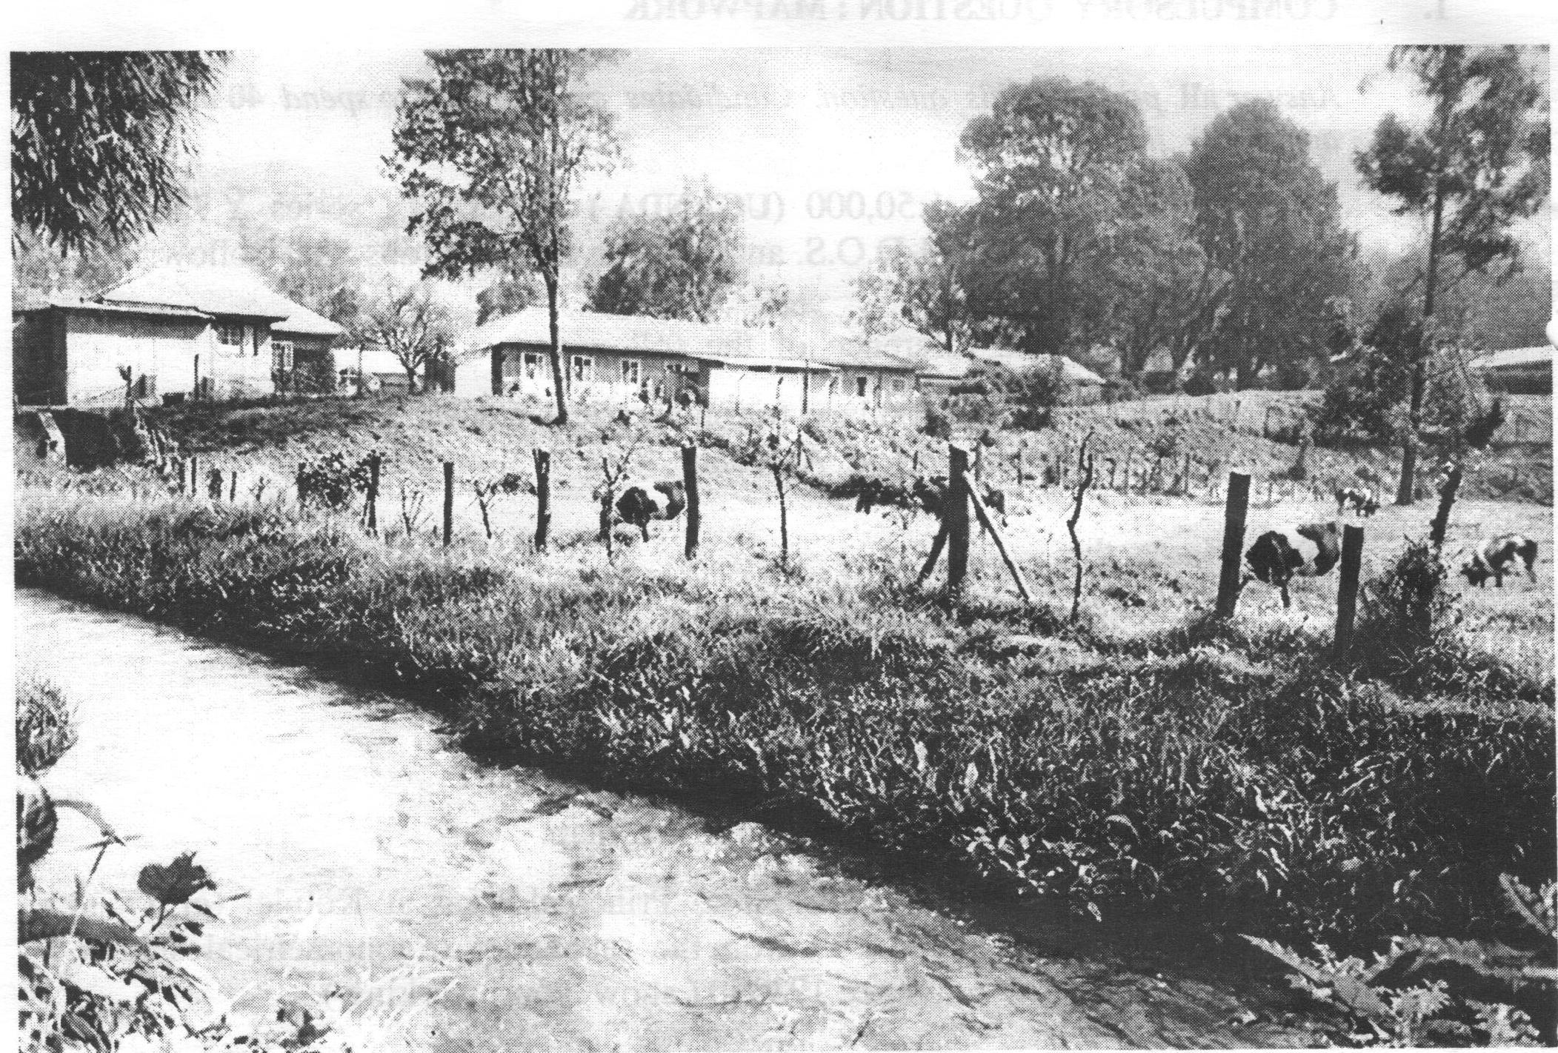

(a). Draw a sketch of the photograph shown and on it, mark and name.**05mks**

(i). Vegetation types.

(ii). Settlement

(iii). Farm area

(iv). Water body

(b). Giving evidences from the photograph, describe the factors which have

favoured the economic activity shown on the photograph **04mks**

(c). Explain the importance of the economic activity to the people living in the area **04mks**

(d). Giving reasons for your answer, suggest an area in East Africa where this

photograph could have been taken. **02mks**

3**. COMPULSORY FIELDWORK QUESTION (15marks)**

Answer all parts of this question.

For any fieldwork study you have carried out either as an individual or a group

(a). State the:

(i). Topic **02mks**

(ii). Objectives of the study **03mks**

(b). Describe the activities carried out in the pre-field work stage. **03mks**

(c). Draw a sketch map of the area studied showing physical and human

features. **04mks**

(d). What were the findings of your fieldwork study? **03mks**

**SECTION B: EAST AFRICA (20MARKS)**

**Answer only one question from this section**

4.(a). Draw a sketch map of East Africa and on it, mark and name,

(i). Equator

(ii). Mountains: Kilimanjaro and Rwenzori

(iii). Water bodies: Albert Nile and L.Malawi

(iv). Eastern branch of the East African rift valley. **07mks**

(b). Describe the processes responsible for the formation of the East African rift valley. **05mks**

(c). Explain the importance of the rift valley to the people of East Africa.**05mks**

(d). Outline the problems faced by people living in the rift valley region of East

Africa. **03mks**

5. Study the climatic statistics of the station below and answer the questions that

follow:

|  |  |  |  |  |  |  |  |  |  |  |  |  |
| --- | --- | --- | --- | --- | --- | --- | --- | --- | --- | --- | --- | --- |
| Months | J | F | M | A | M | J | J | A | S | O | N | D |
| Temperature(0c) | 20 | 22 | 21 | 21 | 21 | 19 | 19 | 20 | 20 | 20 | 19 | 20 |
| Rainfall (mm) | 146 | 157 | 248 | 255 | 314 | 85 | 47 | 85 | 107 | 133 | 163 | 199 |

(a). Draw a suitable graph to show the climaticstatistics of the station above

**08mks**

(b). Calculate the:

(i). Mean annual temperature **02mks**

(ii). Mean annual rainfall for the station above**02mks**

(c). Describe the characteristics of climate at the above station.**05mks**

(d). State the economic activities that can be carried out at the above station.

**03mks**

6.**Study the map of East Africa and answer questions that follow.**

N

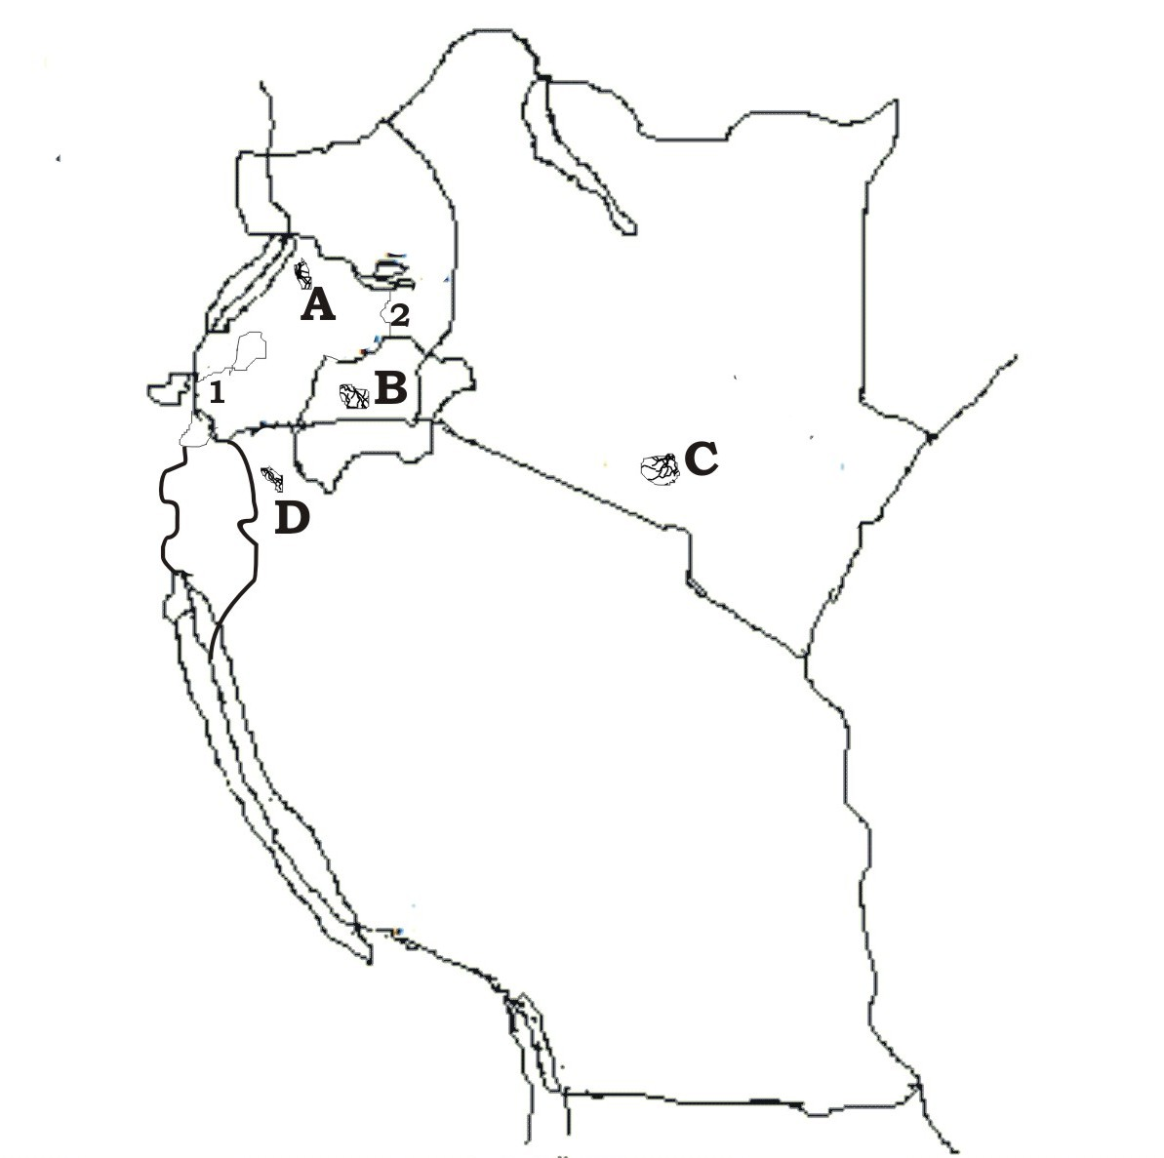

(a). Name the

(i). Forests marked A, B, C and D

(ii). Water bodies marked: 1 and 2 **06mks**

(b). Describe the characteristics of tropical forests in East Africa **04mks**

(c). Describe the conditions which have favoured the growth of tropical forests in

East Africa **04mks**

(d). (i) Identify the human activities thatdestroy tropical forests of East Africa.**03mks**

(ii). Outline the measures being taken to conserve tropical rain forests of East

Africa. **03mks**

7. Study the table below showing the relative importance of fishing grounds in

Uganda and answer the questions that follow.

|  |  |
| --- | --- |
| FISHING GROUND | % AGE CATCH |
| L. Victoria | 58 |
| L.Albert | 10 |
| L. Kyoga | 24 |
| L.George | 06 |
| Others | 02 |

(a). Draw a pie chart to show the relative importance of different fishing grounds

in Uganda. **06mks**

(b). Describe the factors favouring fishing in the fishing grounds above**05mks**

(c). Explain the contribution of the fishing industry to the development of

Uganda **05mks**

(d). Outline the problems faced by people carrying out fishing in the fishing

grounds shown on the table above **04mks**